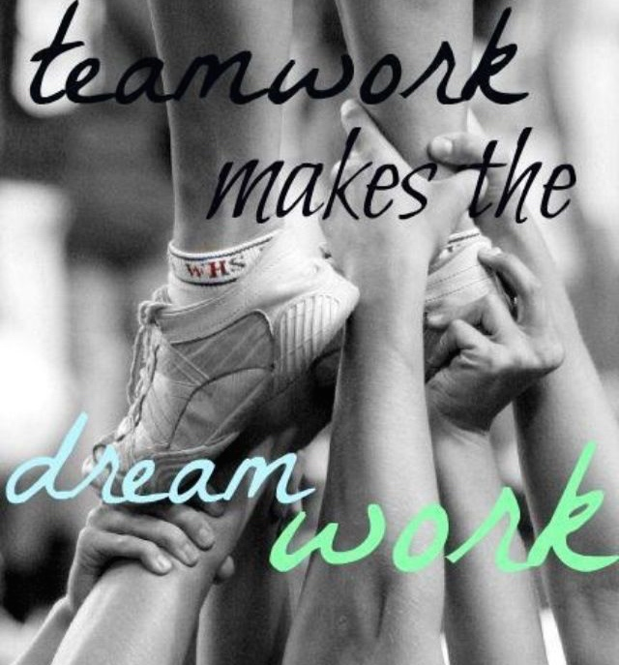

Build your DREAM TEAM

Keys to building strong, unified, productive teams

TEAM WORK is DREAMWORK or is it your nightmare?
Do you feel lost and out of control of your team? Do you have trouble identifying what drives each of your team? Are you tired of all the bickering and excuses from everyone?
If you answered yes to any of these questions then this is the course for you and your team.
OUTCOME
Salon teams will have tools to create a strong, unified team supporting the common mission of the salon. Everyone will feel recognized & understand that they have unique skills & abilities that are both useful & important in creating a successful team. Each person becomes a productive contributor to the team and the business.
Discover what type of team is your team! How do they play? Do they have team mates that they feel they can depend on? Are they someone who the rest of the team can depend on?
Learn about the 5 stages of team development so that you can assess what stage your team is at and what to
steps to do to take them to becoming your DREAM TEAM.
Learn to quickly identify the various personalities of the team, how to best use their unique abilities and how to better communicate with other team mates.
Pull the TEAM together…Understand the importance of a Team Code of Honour and how to create one.

Other: Consectetuer arcu ipsum ornare pellentesque vehicula, in vehicula diam, ornare magna erat felis wisi.

123.456.7890

